Capstone Week 3: Testing Your Hypothesis

This week’s videos and readings focused on the experimental design process and hypothesis testing. This is where the rubber really starts to hit the road when you’re analyzing data!  For this Capstone Week 3 assignment, we want to use what you’ve learned about experimental design, and marketing studies in particular, to formulate and test a hypothesis for your Capstone Dataset spreadsheet.

In our reading on experimental design we discussed the full design process involving five basic steps:

1. Questioning
2. **Hypothesis**
3. **Required Variables**
4. **Choosing a Measurement Approach**
5. Selecting an Analysis

For this week’s Capstone assignment, we will give you an evaluation question, and we’ve already gathered the required data into your Capstone Dataset spreadsheet. So, you will not need to worry about steps 1. and 4., above. Also, we will save step 5. for next week. This week you will focus on steps 2. and 3. of the full experimental design process: *formulating a hypothesis and testing it!*

**1. Formulate a Hypothesis to Answer Your Evaluation Question**

Marketing studies begin with an evaluation question. We noted how these evaluation questions come from many sources. Sometimes you get them from your manager as they evaluate business needs. The question may come directly from a stakeholder or client. You may even come up with an evaluation question yourself, when thinking about your marketing efforts and audience, or ways to help your company.



It’s these evaluation questions that motivate us to form hypotheses—proposed answers to the question at hand—that we can then test through our analysis of data.

For this Capstone Week 3 assignment we want you to analyze the Capstone Dataset data with the following evaluation question in hand:



The first task we want you to address this week is to *write a hypothesis statement that answers this evaluation question.* Recall from our reading, “Experimental Design,” that a good hypothesis addresses three parts:

**Three Parts of a Clear Hypothesis:**

* **What will change?**
* **How will it change?**
* **What will cause the change?**

You should try to formulate your hypothesis to address these three questions. For example, a good hypothesis for the evaluation question above might say something like: “*Our number of conversions* will *be greater* if we *advertise on platform X* rather than platform Y” (where X and Y are one of the platforms, AdWords or Facebook). This hypothesis answers the evaluation question in a way that addresses the three parts of a clear hypothesis.

You will enter your hypothesis into your Capstone Slide Deck slides for week 3.

**2. Determine Your Independent and Dependent Variables**

Once you have formulated your hypothesis, you will need to consider what variables from your dataset are required to test that hypothesis. Recall from the “Experimental Design” reading how, when you conduct an experiment or test, you will typically manipulate one set of variables to see how changes in those variables influence changes measured in some other set of variables. In a test like this, we call the variable that we *manipulate* an *independent variable*. The variable whose effect we *measure* is called a *dependent variable*. In terms of the parts of a clear hypothesis statement, the dependent variable will be what addresses the question of “what will change;” and the independent variable will be what addresses the question of “what will cause the change.” So, you should be able to infer your independent and dependent variables from the hypothesis you formulated above!

Consider the evaluation question and your hypothesis for this assignment to *determine the independent and dependent variables for testing your hypothesis*. You will enter these into your Capstone Slide Deck slides for week 3.

**3. Test Your Hypothesis**

It’s time to test your hypothesis. It is quite clear from the evaluation question you were given that your test will involve a comparison: you were asked to compare Facebook and AdWords Conversion data. This is typical of marketing analytics questions! It is also why we said, in the readings on “Hypothesis Testing and A/B Tests” and “More on Hypothesis Testing,” that hypothesis tests are framed in terms of the question: “Is there a  difference?”

You learned how this question implies two possible answers, or *two hypotheses*:



We call the first hypothesis (H0) the **null hypothesis**. We refer to the second hypothesis (H1) as the **alternative hypothesis**. Hypothesis tests are designed to determine which of these hypotheses—the null hypothesis or the alternative hypothesis—is the true one. This is what you need to do for the hypothesis you formulated above. You should begin by getting clear on what the null and alternative hypotheses are for your hypothesis test. (Hint: “population A” and “population B” are just the two things that your evaluation question asked you to compare.)

Here are the things you should do to test your hypothesis:

a. *Calculate the mean values for the “Facebook Ad Conversions” and “AdWords Ad Conversions”* data you were given in your Capstone Dataset. (Remember: you can do this in Excel or Google Sheets with the **=AVERAGE** formula.) This will tell you whether there is *any overall difference* between “Facebook Ad Conversions” and “AdWords Ad Conversions.”

b. Next, you need to determine whether this overall difference is *a statistically significant difference*. You learned to do this by comparing the **p-value** for your data to some given **Alpha** value (𝛂). For a refresher on this, refer back to the “More on Hypothesis Testing” reading. We are giving you an Alpha of 5% (𝛂 = 0.05); but you will need to *calculate the p-value* for yourself. You can calculate the p-value in an Excel or Google Sheets spreadsheet by applying the t-test formula we gave you in this week’s readings and videos:



(In the t-test formula, “A:A” refers to the column of “Facebook Ad Conversions” data and “B:B” to the column of “AdWords Ad Conversions.”) If your t-test formula gives you a *p-value that is less than 𝛂*, then that means the difference between “Facebook Ad Conversions” and “AdWords Ad Conversions” is *a statistically significant difference*.

c. Given what you’ve discovered about whether there’s a statistically significant difference in the data, *what does this tell you about whether to accept the null hypothesis or the alternative hypothesis?*

d. Finally, putting it all together: *What’s your conclusion about your main hypothesis? Is there a difference, and is it what your hypothesis predicted?*

You will enter these test results into your Capstone Slide Deck slides for week 3.

**Your Turn!**

Here’s an outline of how the above tasks might be completed for the data from our Capstone Dataset spreadsheet. You’ll notice that you only need to use spreadsheet formulas for tasks 3.a and 3.b.

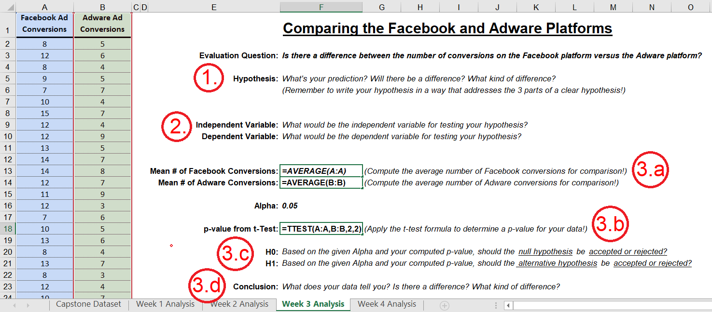

Now it’s your turn! Can you *complete these tasks for the Capstone Dataset and the evaluation question you were given above*?